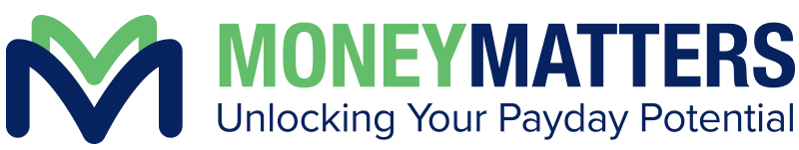
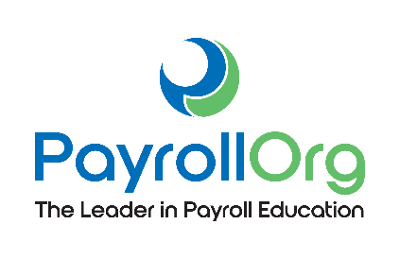

Q: What is Money Matters?

A. Money Matters is an annual campaign that empowers payroll and finance professionals to educate the upcoming generations of employees on paycheck basics. This financial literacy program was founded by PayrollOrg (PAYO) and is held annually in conjunction with National Payroll Week.

Q. What important topics will students learn from a Money Matters lesson?

A. After going through the exclusive Money Matters “Bringing Home the Gold” lesson plan,
students will have a basic understanding of:

• The payroll withholding system
• How a paycheck is calculated
• How to complete a Form W-4 on their first day of work
• The pros and cons of various payment methods available to them

Q. Is the Money Matters lesson an in-person or virtual presentation?

A. The Money Matters lesson is optimized for both in-person or virtual delivery depending on your presentation preference. You can watch this video as an example of how to present virtually.

Q. Will PAYO tell me where to present the lesson?

A. No, it is up to the volunteer to decide where and when you are going to teach the Money Matters lesson. The lesson is geared towards students who are receiving their first paycheck (i.e. high schoolers), however other people besides students could benefit from this presentation. We would suggest reaching out to local schools, youth groups, and non-profits to find a group of young adults you could present to. In the past, there have been presentations at schools, churches, to boy scout and girl scout troops, etc.

Q. How long does it take to teach the Money Matters curriculum?

A. On average, it takes one hour to present the Money Matters curriculum. Presentation times can vary based on how many questions volunteer presenters receive from students.

Q. Why do you need a Money Matters lesson at your location?

A. Financial illiteracy is a major problem in the United States. After being exposed to the hands-on Money Matters presentation, students will have the knowledge and understanding to take control of the way they are paid, save for the future, and put more money in their pocket with each paycheck.

Q. Is there a fee to have a Money Matters lesson presented?

A. No! There is never a charge for this presentation.

Q. What is PayrollOrg?

A. Established in 1982, PayrollOrg is the nation’s leader in payroll education, publications, and training. The Money Matters program is part of PAYO’s nonprofit, volunteer outreach efforts to increase financial literacy.

