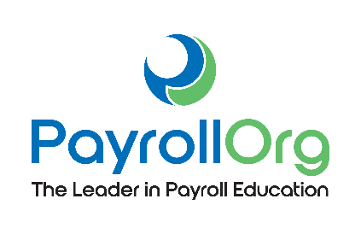

[Date]
[School Address]
Dear [School Administrator],
I am with the [Chapter Name] of PayrollOrg (PAYO), a professional organization with more than 30,000 members nationwide. I am reaching out to ask permission to teach your students about their paychecks and the payroll withholding system on [Date] as part of our Money Matters campaign.
The lesson will provide real-world financial literacy training for your students. They will acquire an understanding of how and why payroll taxes are withheld from their paychecks and learn to fill out the Form W-4. Since your students will soon be working, this personal finance knowledge will be indispensable as they strive to become financially responsible adults.
Depending on your preference and safety measures in place at [School Name], I can visit your campus to present the Money Matters lesson in-person, or the lesson can also be taught to students virtually. My lesson plan and student materials are optimized for both in-person or virtual delivery.
Currently, 78 percent of employees in America live paycheck to paycheck. With my presentation, I will arm your students with the knowledge and understanding to improve their money management skills, save for the future, and put more money in their pocket with each paycheck.
I have enclosed the lesson plan that I will teach from, created by PAYO and the Council for Economic Education, for you to review. It is geared toward teens entering the workforce and designed to take approximately one hour. The lesson can be shortened or lengthened depending on the times you have available. There is no charge for this presentation, as it is part of PAYO’s nonprofit, volunteer outreach program to increase payroll and financial literacy.
I will contact you within a week to discuss participation details. For more information, please visit www.nationalpayrollweek.com/about-money-matters/. I look forward to partnering with you and [School Name].
Best regards,
[Member Name]
[Address]
[Phone]

